Student’s Name
Date
Myrtle Beach
Myrtle Beach is on the South Carolina’s Atlantic Coast and serves as a vacation resort competing with popular destinations such as the Caribbean. The city boasts of a significant number of visitors, which overlooks the approximately 30,000 residents, all of whom get to enjoy warm weather, wide beaches, and a diverse rang of entertainment activities, live theatre, dining, shopping, nightlife, and golf. The beach serves as the home to vacation homes, oceanfront condos, high-rise resorts and hotels, and smaller “mom-and-pop” inns and motels to serve its diverse target audience. The structure and orientation of Myrtle Beach includes several theme and adventure parks as a nod to its strong orientation for family. The history of Myrtle Beach as a tourist spot starts out with the Spanish in 1526, but became popular in the 1900s while it was quite rustic. The name “Myrtle Beach” replaced the previous name for the location “Long Bay, Withers and New Town” in 1900.
The history of the beach also includes its period as a military camp. Both the Myrtle Beach Air Force Base and the U.S. Army Air Corps called the destination home in the 20th century. In commemoration of the period and military personnel and civilians working in the base, the site has the renowned “Wall of Service” as a part of its Warbird Park features. The park also displays threw different tips of U.S. Air Force plans stationed on the base. A critical part of the beach’s vibrant history is its golf evolution and events. The notable mentions in the field and current stature of on hundred 18-hole equivalent courses provides a compelling argument to mention Myrtle Beach as the Golf Capital of the World.

Photo 1: Aerial view of Myrtle Beach overlooking a theme park, and high-rise
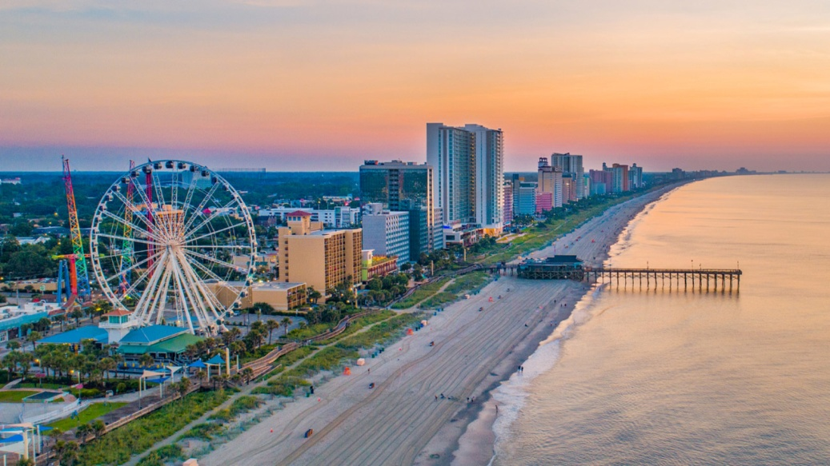
Figure 1: BBC News
Photo 2: Satellite view of Myrtle Beach
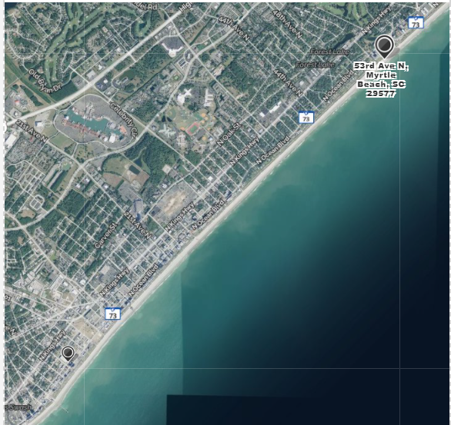
Figure 2: Mapquest

